 | CS607-  ASSIGNEMN-2  JUNAID MALIK | 
Junaidfazal08@gmail.com  Bc190202640@vu.edu.pk | FOR MORE VISIT VULMSHELP.COME | JUNAID MALIK  0304-1659294

QUESTION NO 1:
SOLUTION:
Fuzzy rule | Product demand | Production cost | Success rate
If product demand is high THEN success rate is high | High | Low, medium, or high | High
If production cost is low THEN success rate is high | Low, medium, or high | Low | High

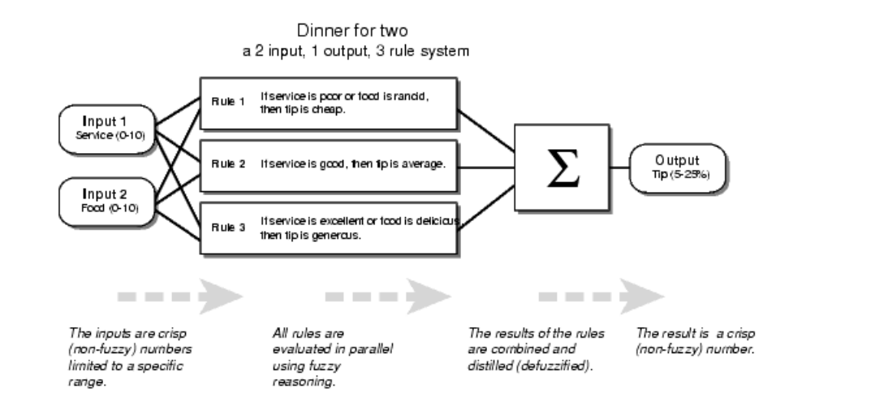

QUESTION NO 2:
SOLUTION:
(printout t "JUNAID MALIK" crlf)
(printout t "0304 1659294" crlf)
(crlf)

(deftemplate product
(slot id)
(slot name)
(slot category)
(slot price))

(deffacts initial-facts
(product (id 1) (name "Strawberry") (category "Dairy") (price 2.99))
(product (id 2) (name "Cake") (category "Dairy") (price 4.99))
(product (id 3) (name "Yogurt") (category "Dairy") (price 1.99))
(product (id 4) (name "Butter") (category "Dairy") (price 3.49))
(product (id 5) (name "Ice Cream") (category "Dairy") (price 5.99))
)

(defrule remove-fact
?p <- (product (id 3))
=>
(retract ?p)
(printout t "Fact 3 has been retracted." crlf)
)

(defrule display-facts
=>
(facts)
)

(reset)
(run)

